Installation of Hadoop

sudo apt update

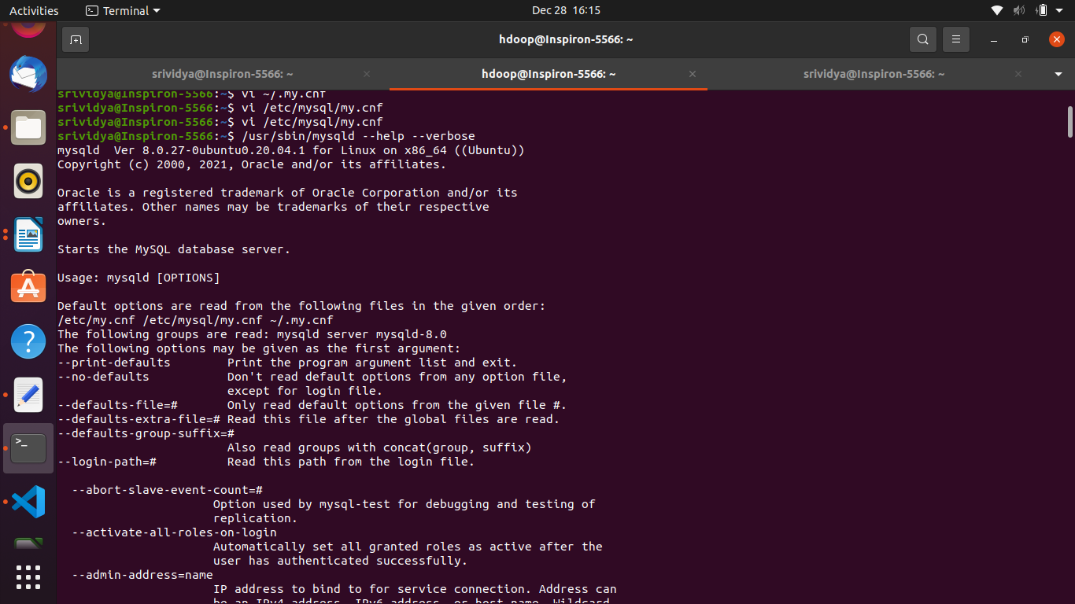

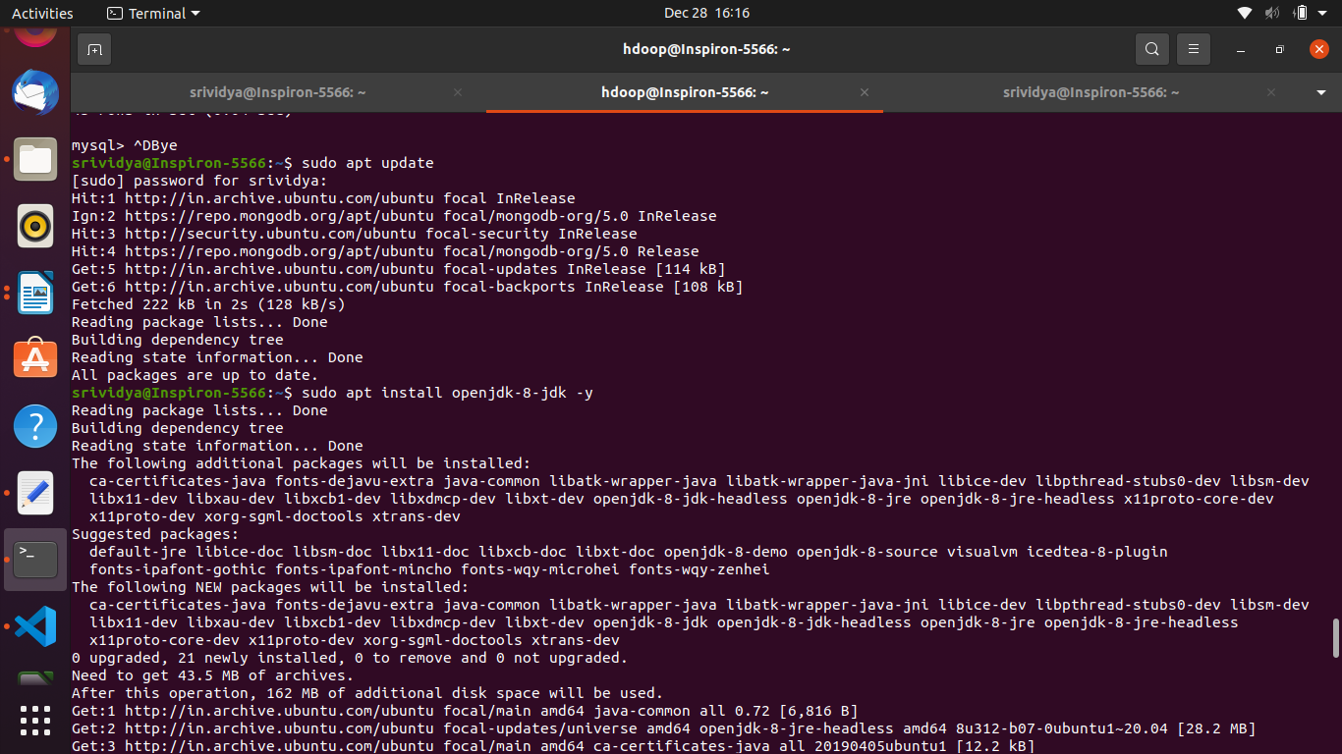

**$sudo apt install openjdk-8-jdk openjdk-8-jre**

**$ java -version (to get version)**

**sudo apt install openssh-server openssh-client -y**

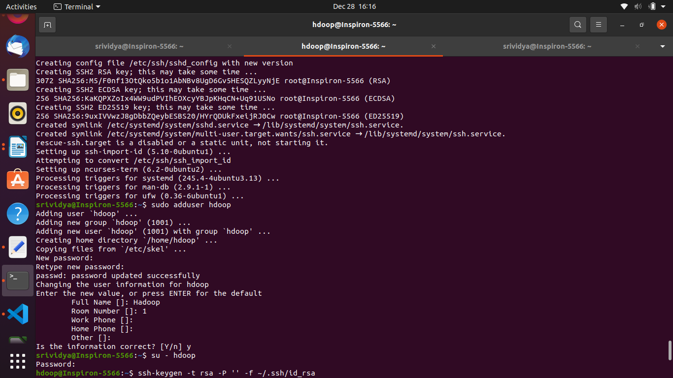

sudo adduser hdoop

su - hdoop

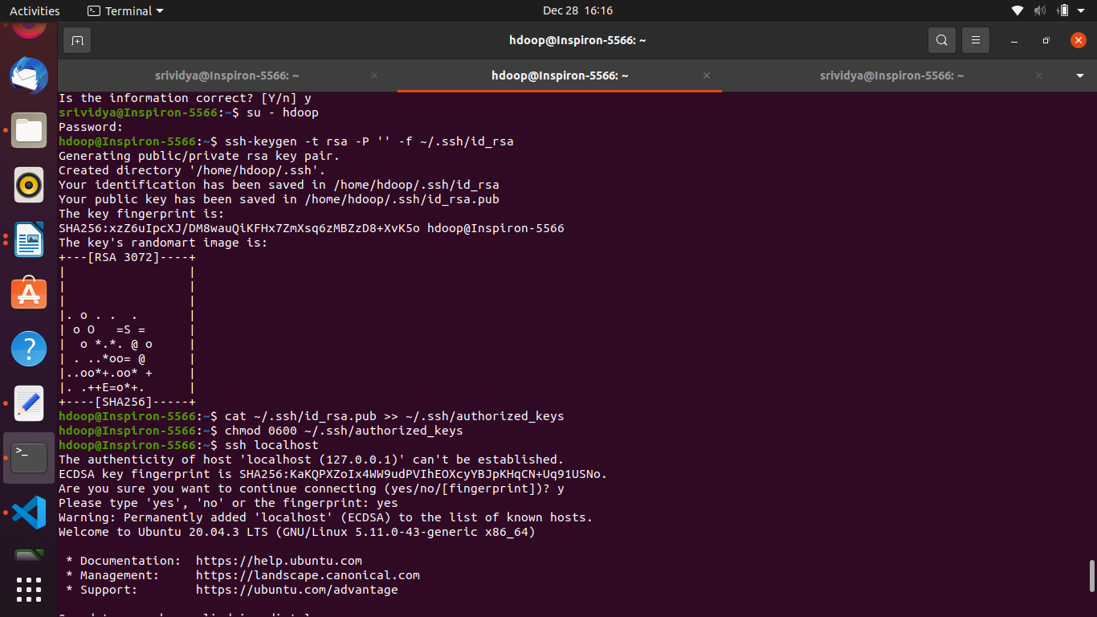

ssh-keygen -t rsa -P '' -f ~/.ssh/id_rsa

cat ~/.ssh/id_rsa.pub >> ~/.ssh/authorized_keys

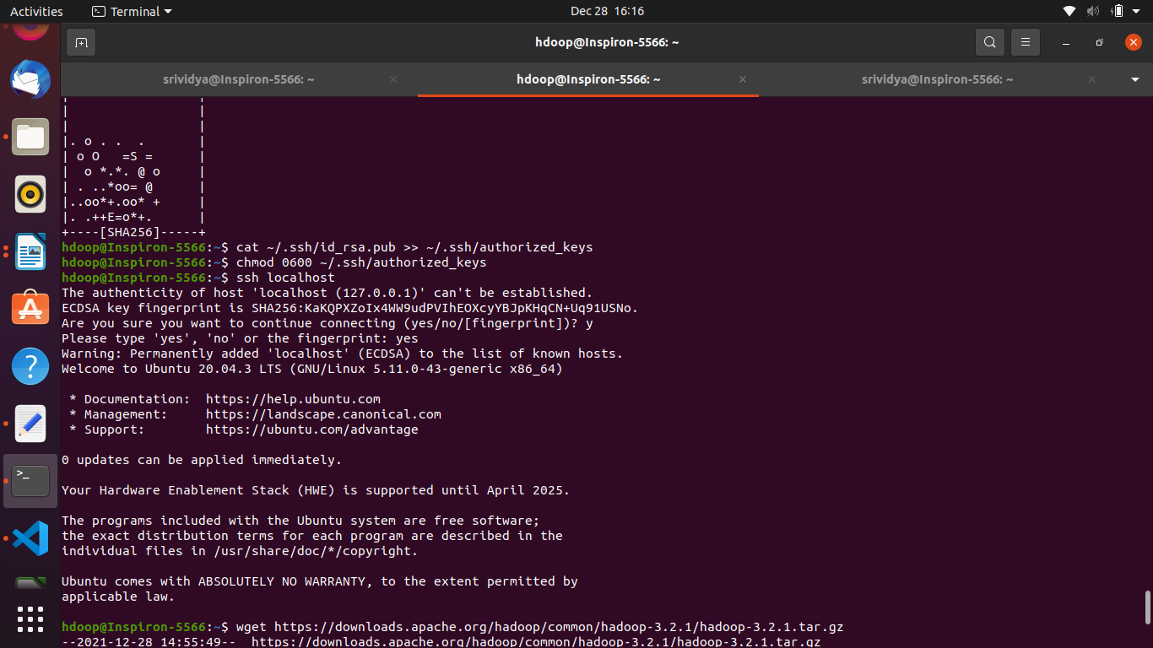

chmod 0600 ~/.ssh/authorized_keys

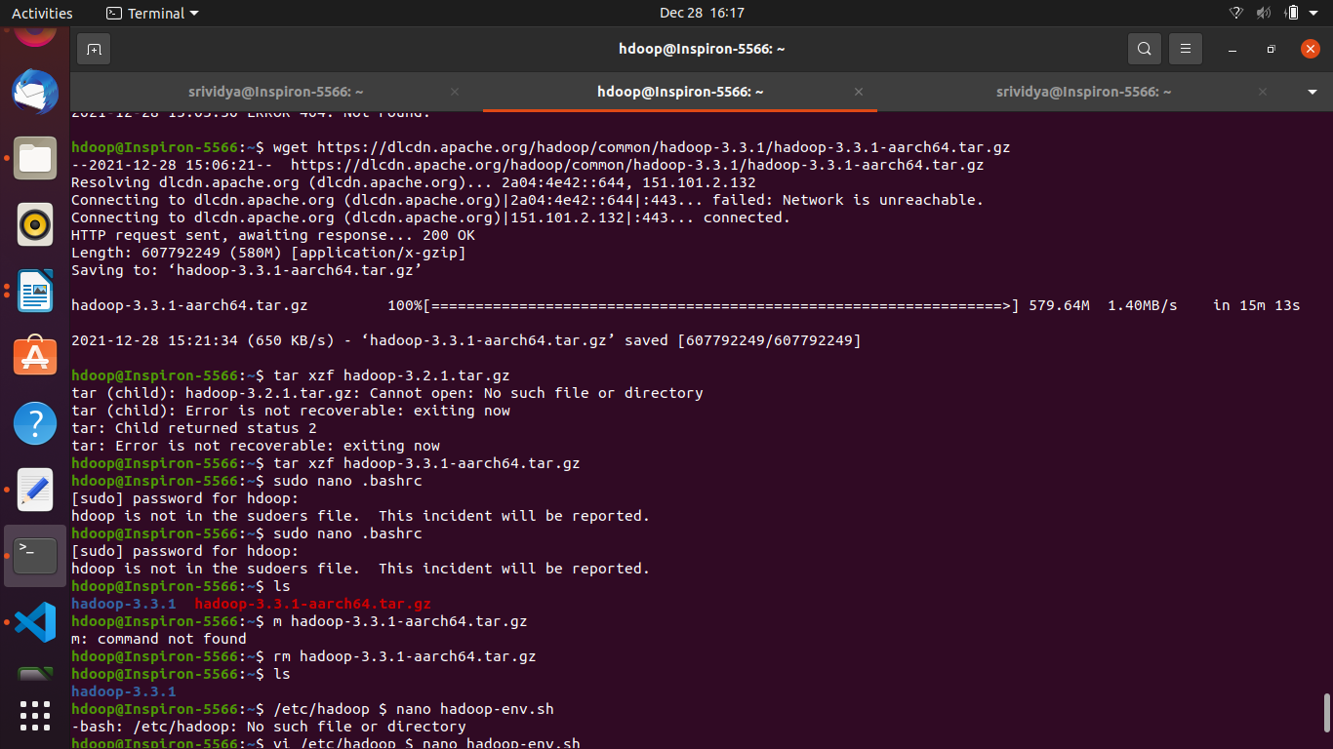

ssh localhost

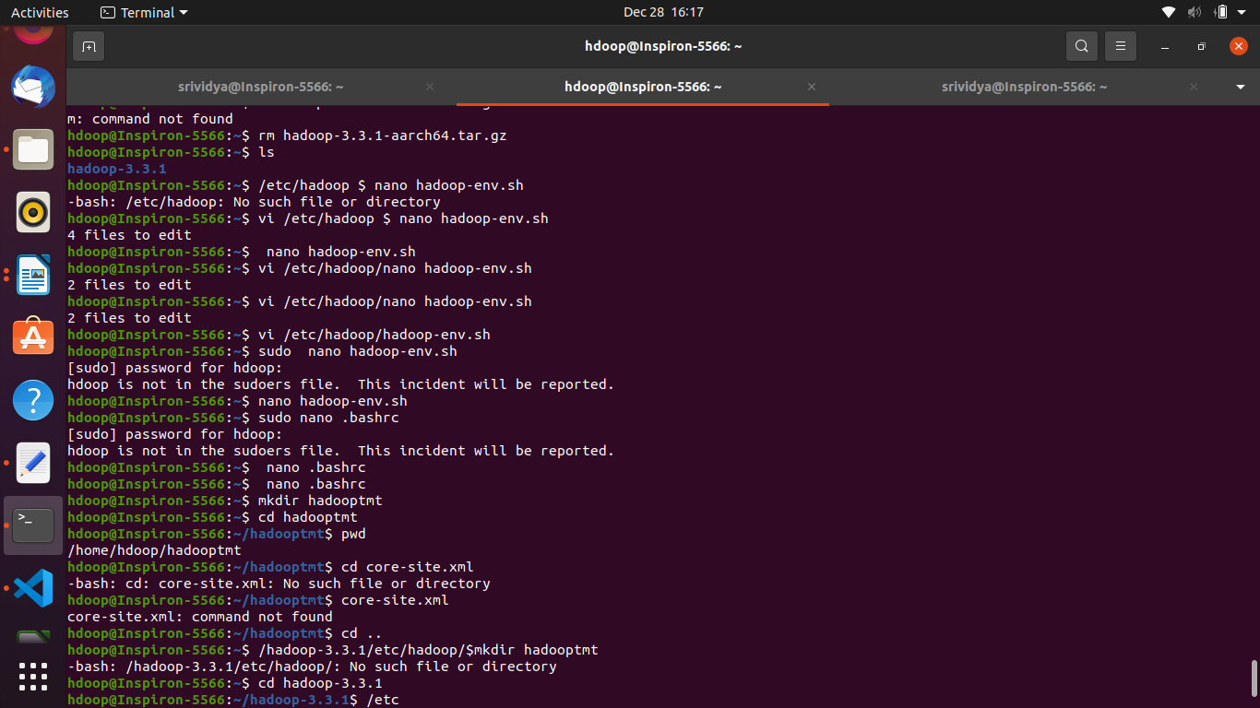

**Go to apache official website and download apache hadoop 3.3.1 version binary64 ----> backupsites copy link**

**In terminal**

**$wget (paste link) https://downloads.apache.org/hadoop/common/hadoop-3.3.1/hadoop-3.3.1-aarch64.tar.gz**

**$ sudo nano .bashrc**

export **JAVA_HOME=/usr/lib/jvm/java-8-openjdk-amd64**

export **HADOOP_HOME=/home/hadoop-3.3.1**

export HADOOP_INSTALL=$HADOOP_HOME

export HADOOP_MAPRED_HOME=$HADOOP_HOME

export HADOOP_COMMON_HOME=$HADOOP_HOME

export HADOOP_HDFS_HOME=$HADOOP_HOME

export YARN_HOME=$HADOOP_HOME

export HADOOP_COMMON_LIB_NATIVE_DIR=$HADOOP_HOME/lib/native

export HADOOP_OPTS="-Djava.library.path=$HADOOP_HOME/lib"

export PATH=$PATH:$HADOOP_HOME/sbin:$HADOOP_HOME/bin:$JAVA_HOME/bin

